CS 340 Project Two: README
Developer: Justin Carlo Florida

About the Project/Project Title

Grazioso Salvare Rescue Dashboard

This project completes a full-stack client/server dashboard for Grazioso Salvare, an international rescue-animal training organization. The application uses the Austin Animal Center Outcomes data stored in MongoDB and the reusable AnimalShelter CRUD Python module developed in Project One. The completed Dash web application allows authorized users to retrieve, filter, analyze, and visualize shelter-animal records through an interactive data table, a breed-distribution chart, and a geolocation map.

Motivation
Grazioso Salvare needs an efficient way to identify dogs that match the characteristics required for different search-and-rescue roles. The dashboard reduces the need to manually search a large animal-shelter data set by providing intuitive rescue-type filters for Water Rescue, Mountain or Wilderness Rescue, and Disaster or Individual Tracking. MongoDB performs the database filtering, while Dash callbacks dynamically update the table and visualizations. This design gives the client a reusable and user-friendly interface for locating suitable rescue candidates.

Required Functionality
The completed dashboard starts with an unfiltered view of the Austin Animal Center data and allows the user to select a rescue category through radio-button controls. Each selection sends the appropriate query through the AnimalShelter middleware to MongoDB. The resulting records are displayed in the interactive DataTable and used to update the dashboard visualizations.

Reset displays the complete, unfiltered animal data set.

Water Rescue filters by the required breeds, intact-female sex, and 26–156 week age range.

Mountain or Wilderness Rescue filters by the required breeds, intact-male sex, and 26–156 week age range.

Disaster or Individual Tracking filters by the required breeds, intact-male sex, and 20–300 week age range.

The DataTable supports single-row selection, native sorting, native filtering, and pagination.

The Plotly pie chart dynamically displays the breed distribution of the currently displayed records.

The Dash Leaflet map displays the location of the selected animal and identifying information in the marker popup.

The dashboard includes the Grazioso Salvare logo, a link from the logo to the client home page, and the developer identifier.
Getting Started
To reproduce and run the completed Project Two dashboard:
- Import the Austin Animal Center Outcomes CSV data into the animals collection of the aac MongoDB database.

- Create or verify the aacuser account with read/write access to the aac database.

- Open the project in Codio and launch Jupyter Notebook.

- Place CRUD_Python_Module.py, ProjectTwoDashboard.ipynb, and the provided Grazioso Salvare logo in the working project directory.

- Verify the MongoDB host, port, database, and collection settings in CRUD_Python_Module.py.

- Provide the valid aacuser credentials when the AnimalShelter class is instantiated in ProjectTwoDashboard.ipynb.

- Restart the Jupyter kernel and run the dashboard notebook from the beginning.

- Open the Dash application link generated by the notebook.

- Test the starting state and each rescue filter, then verify that the DataTable, breed chart, and geolocation map update correctly.

Installation and Tools
The following software, frameworks, and libraries were used to complete Project Two:

Codio and Jupyter Notebook – development and execution environment.

Python 3 – application and middleware programming language.

MongoDB – document-oriented database used as the model/data layer.

PyMongo – Python driver used by the AnimalShelter class to connect to and query MongoDB.

Dash/JupyterDash – framework used to create the dashboard view and callback-based controller behavior.

Dash DataTable – interactive presentation of animal records with sorting, filtering, selection, and pagination.

Plotly Express – used to create the dynamic breed-distribution pie chart.

Dash Leaflet – used to create the dynamic geolocation map.

Pandas – converts MongoDB query results into DataFrames and Dash-compatible records.
Tools and Design Rationale
MongoDB was used as the model component because its document-oriented structure works naturally with the animal records in the Austin Animal Center data set. MongoDB queries support filtering by fields such as breed, sex, animal type, and age, and PyMongo allows those queries to be issued directly from Python. The AnimalShelter class centralizes the database connection and CRUD operations so the client-facing application does not duplicate database-access logic.
Dash provides the view and controller portions of the web application. The layout defines the user interface, including the radio-button controls, DataTable, chart, and map. Dash callbacks act as the controller by responding to user selections and updating other components. This follows the Model-View-Controller approach used in the course: MongoDB is the model, dashboard widgets are the view, and callback logic coordinates the interface with the CRUD middleware.

Usage
After the dashboard opens, the user selects a rescue type from the radio-button controls. The callback constructs the corresponding MongoDB query and passes it to db.read(). The returned documents populate the DataTable. The chart uses the table's current data to display breed distribution, and selecting an animal row updates the geolocation map. Selecting Reset returns the dashboard to the complete unfiltered data set. Users can also sort columns, enter native DataTable filters, and move between pages of results.

Development Steps
- Reused and documented the AnimalShelter CRUD Python module from Project One as the middleware layer.

- Connected ProjectTwoDashboard.ipynb to MongoDB through the authenticated aacuser account.

- Loaded the initial unfiltered data set and removed MongoDB ObjectId values before sending records to Dash.

- Created the dashboard layout with Grazioso Salvare branding, developer identifier, rescue-type controls, DataTable, chart area, and map area.

- Created MongoDB queries for the three rescue categories using the required breed, sex, and age criteria.

- Created a Dash callback that sends the selected rescue query to MongoDB and updates the DataTable.

- Created a Plotly pie-chart callback based on the DataTable's current visible data.

- Created a Dash Leaflet callback that displays the selected animal's latitude and longitude on a map.

- Added native DataTable sorting, filtering, single-row selection, and pagination.

- Added the required link from the Grazioso Salvare logo to the client home page.

- Restarted the Jupyter kernel and tested the starting state and every required rescue filter.

Challenges and Solutions
One challenge encountered during testing was a MongoDB authentication failure. The Dash application could start, but the DataTable and visualizations were empty because the database read operation could not authenticate. The issue was resolved by verifying the aacuser credentials and rerunning the notebook, after which the MongoDB records populated the dashboard normally.
Another challenge occurred while updating the header so the Grazioso Salvare logo would act as a link. A mismatched indentation/bracket structure caused an IndentationError in the notebook. The layout was corrected by keeping the linked image inside the html.Center container and matching the surrounding brackets and indentation. The notebook was then restarted and tested again successfully.
The dynamic visualizations also required careful callback design. The breed chart was connected to the DataTable's current visible data rather than the original unfiltered DataFrame so it reflects the active rescue selection and native table filtering. The map callback also handles an empty selected-row list by using the first visible record, preventing the map from failing when filters change.

Tests and Screenshots
The final dashboard was tested after restarting the Jupyter kernel and running the notebook from the beginning. Testing confirmed database authentication, MongoDB filtering, DataTable sorting and native filtering, pagination, row selection, dynamic chart updates, map updates, Reset behavior, and the clickable Grazioso Salvare logo.

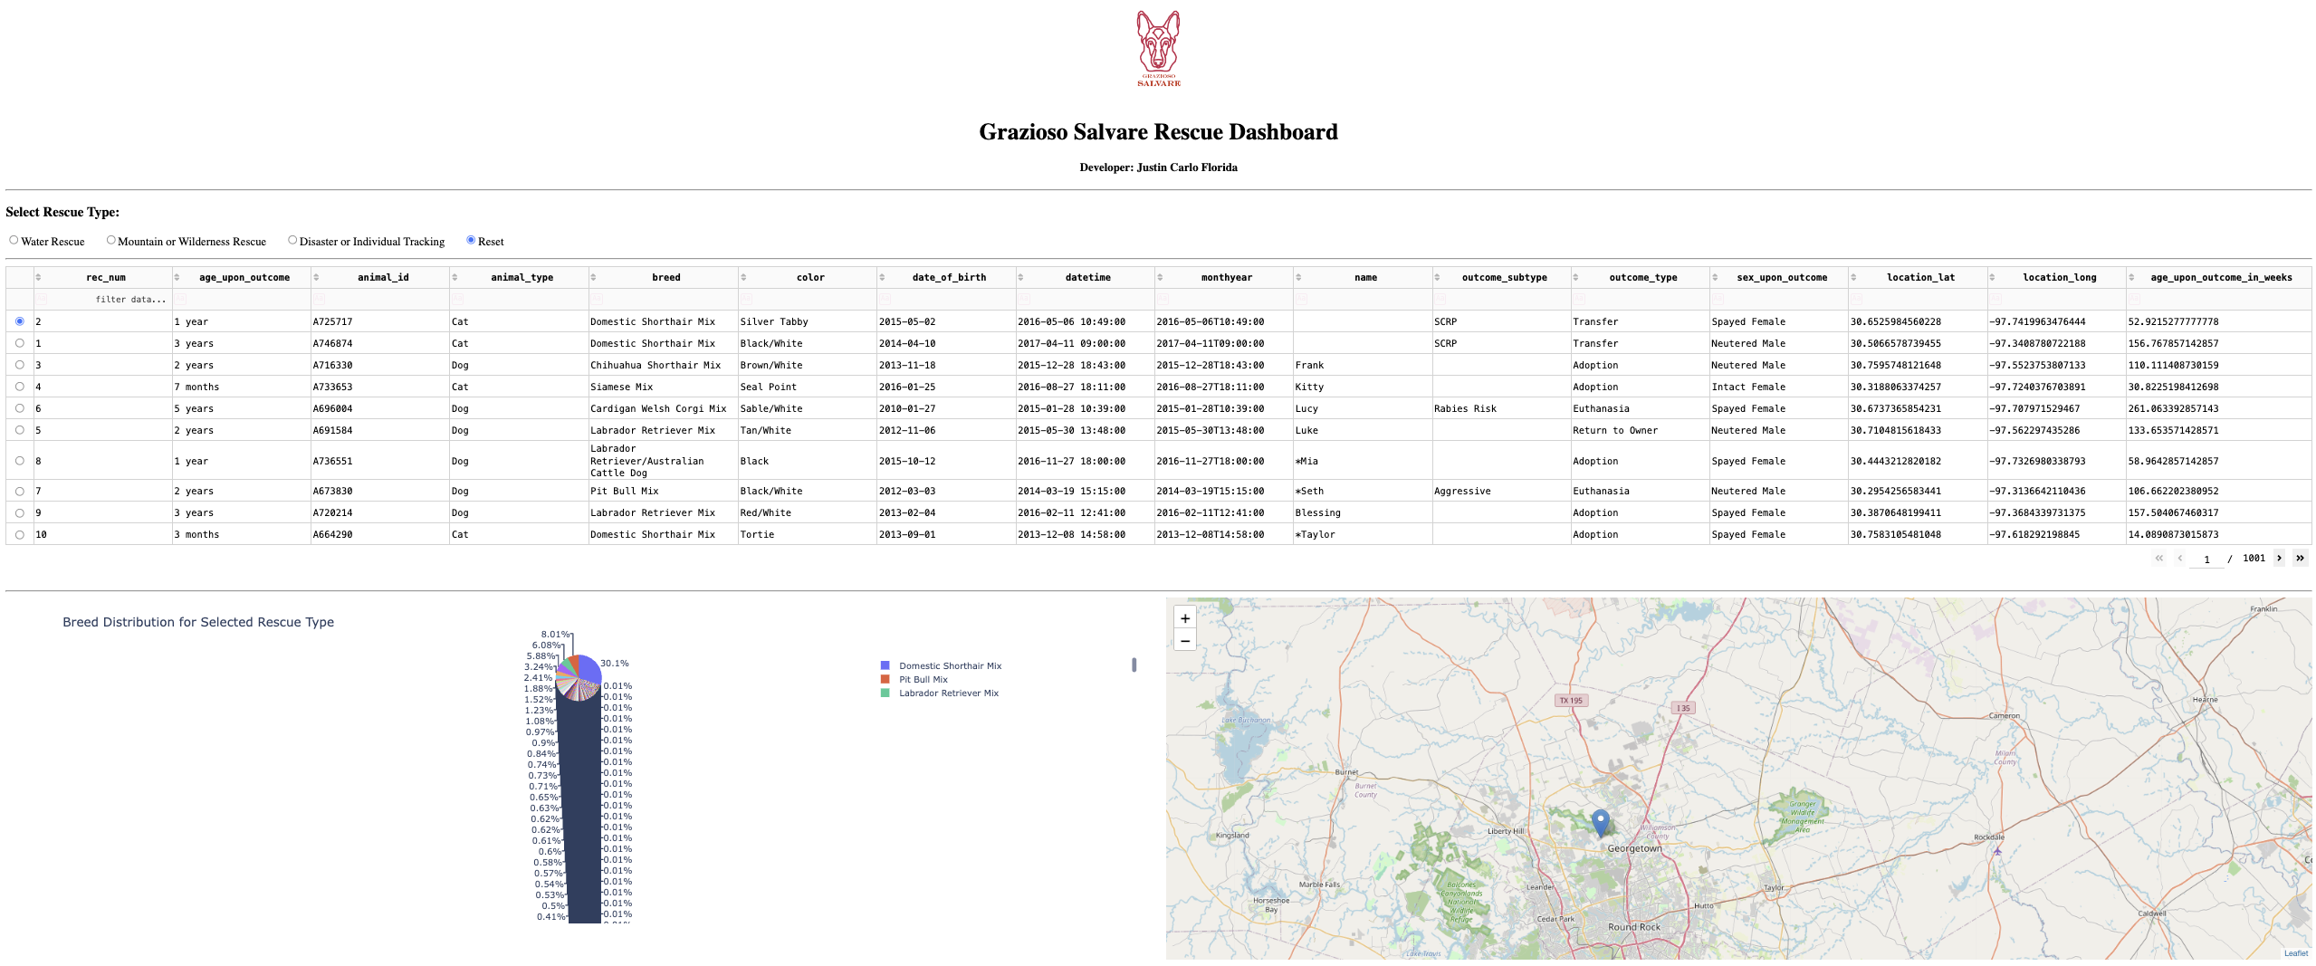
Figure 1. The dashboard in its initial unfiltered state, displaying the complete Austin Animal Center data set, interactive DataTable, breed-distribution chart, and geolocation map.
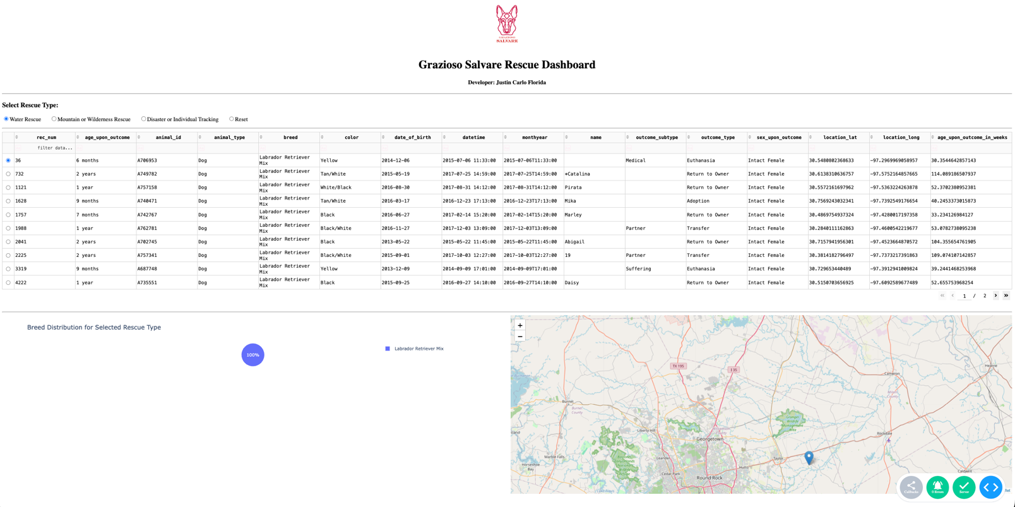
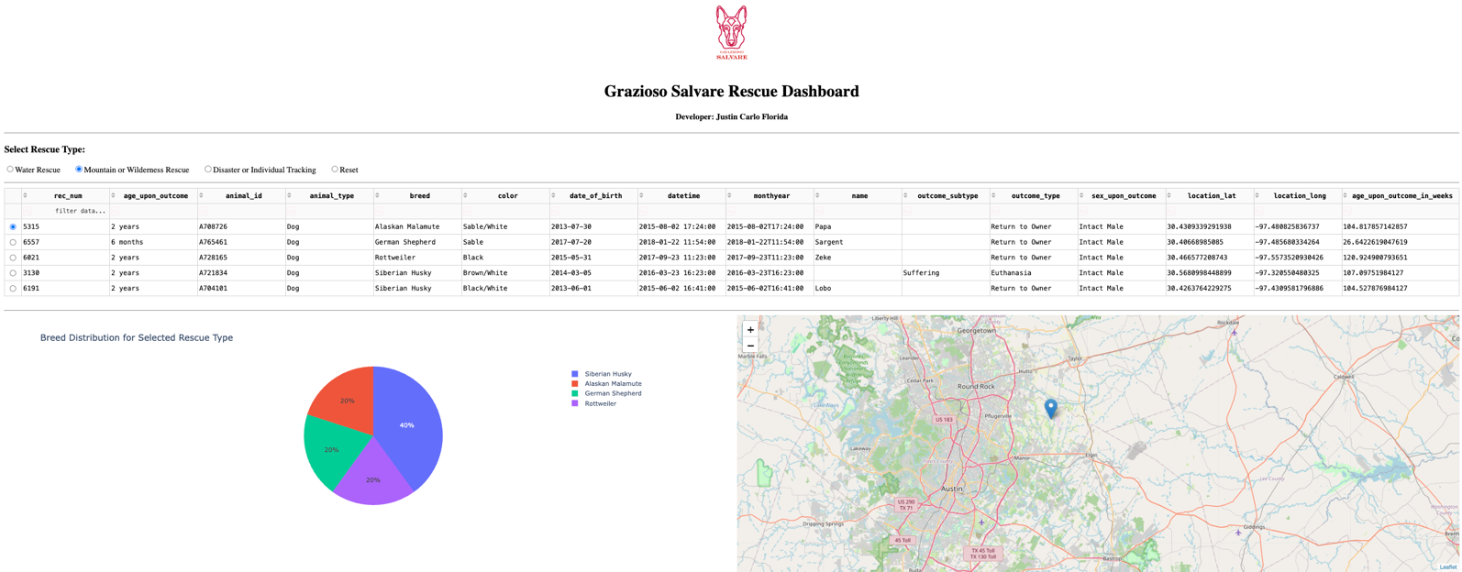
Figure 2. The Water Rescue filter applied. The DataTable and visualizations dynamically update to show animals that match the required Water Rescue criteria.

Figure 3. The Mountain or Wilderness Rescue filter applied. The dashboard dynamically displays animals that match the required wilderness-rescue criteria.
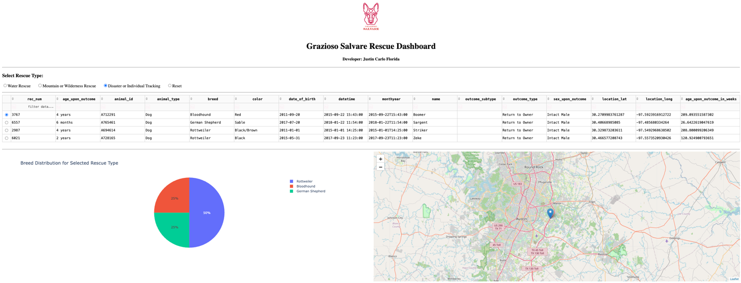
Figure 4. The Disaster or Individual Tracking filter applied. The DataTable, breed chart, and map update to show matching rescue candidates.

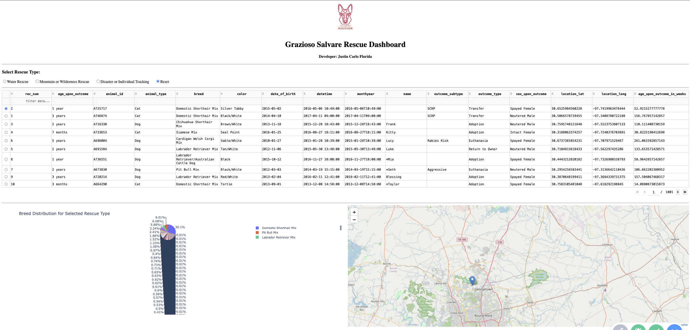
Figure 5. The Reset option applied, returning the DataTable and visualizations to the original unfiltered state.

Resources

Plotly. (n.d.). Dash Core Components. Dash for Python Documentation.
https://dash.plotly.com/dash-core-components

Plotly. (n.d.). Sorting, filtering, selecting, and paging natively. Dash for Python Documentation.
https://dash.plotly.com/datatable/interactivity

Dash Leaflet. (n.d.). Dash Leaflet documentation.
https://www.dash-leaflet.com/

Plotly. (n.d.). Pie charts in Python. Plotly Python Open Source Graphing Library.
https://plotly.com/python/pie-charts/

MongoDB, Inc. (n.d.). MongoDB PyMongo documentation. MongoDB Documentation.
https://www.mongodb.com/docs/languages/python/pymongo-driver/current/

Python Software Foundation. (n.d.). PEP 8 – Style guide for Python code. Python Enhancement Proposals.
https://peps.python.org/pep-0008/

Southern New Hampshire University. (n.d.). CS 340 Dashboard Specifications Document. Course-provided supporting material.

Austin Animal Center. (2020). Austin Animal Center Outcomes [Data set]. City of Austin, Texas Open Data Portal.
https://doi.org/10.26000/025.000001

Roadmap/Features
Project Two completes the planned integration of the Project One CRUD middleware with the client-facing Dash application. The current version supports database-backed rescue filtering, an interactive table, dynamic data visualization, geolocation, and client branding. Possible future enhancements could include additional search controls, more chart types, improved responsive styling, and deployment outside the course development environment.

Contact
Developer: Justin Carlo Florida
Southern New Hampshire University
CS-340 Client/Server Development

